**Researcher Name**: Adebanjo Ambrose Falade

## **Email:** [faladeadebanjo@gmail.com](mailto:faladeadebanjo@gmail.com)

**Completed project for Azure: (AZ:104)**

**Implement the Azure IaaS**

**DESCRIPTION**

OSS Corporation is a globally distributed firm. They have their headquarters in the **East US** with another branch office in the **WEST US**. Currently, they are working on a project and decided that the application tier of this project will reside in one of its branch regions. For security reasons, OSS Corporation management is adamant on keeping their data tier in the headquarter region.

**Background of the problem statement:**

As an organization, they are open to suggestions and are currently evaluating Azure as a deployment platform. To prepare for the deployment of IaaS **Standard_B1ms**, OSS Corporation must deploy an IaaS v2 virtual network in the headquarters region for its database. But for the application, it should create another IaaS v2 virtual network in the branch region. In addition, because the communication between App and data should happen over a private channel, one needs to prepare their branch office virtual network for establishing connectivity to the headquarter’s IaaS v2 virtual network by creating a virtual network gateway and deploy a test

IaaS **Standard_B1ms** VM to the virtual networks for verifying the connection.

After the deployment team ensures the connectivity between both the networks, you can validate the same using Ping.

**Following requirements should be met:**

* Create virtual networks in the before mentioned region
* Create test virtual machines in both the virtual networks
* Establish the connectivity between both the networks via VNet peering
* Ensure connectivity is established properly

Step1: Create virtual networks in the aforementioned region

Step A: Create First Virtual Network in HeadQuaters (East US) Region

CIDR VNET: 10.104.0.0/16

CIDR Subnet: 10.104.0.0/24

Resource Group Name: OSS_rg1_HQ VNET Name: VNET1

Subnet Name: SN1 Location: East US

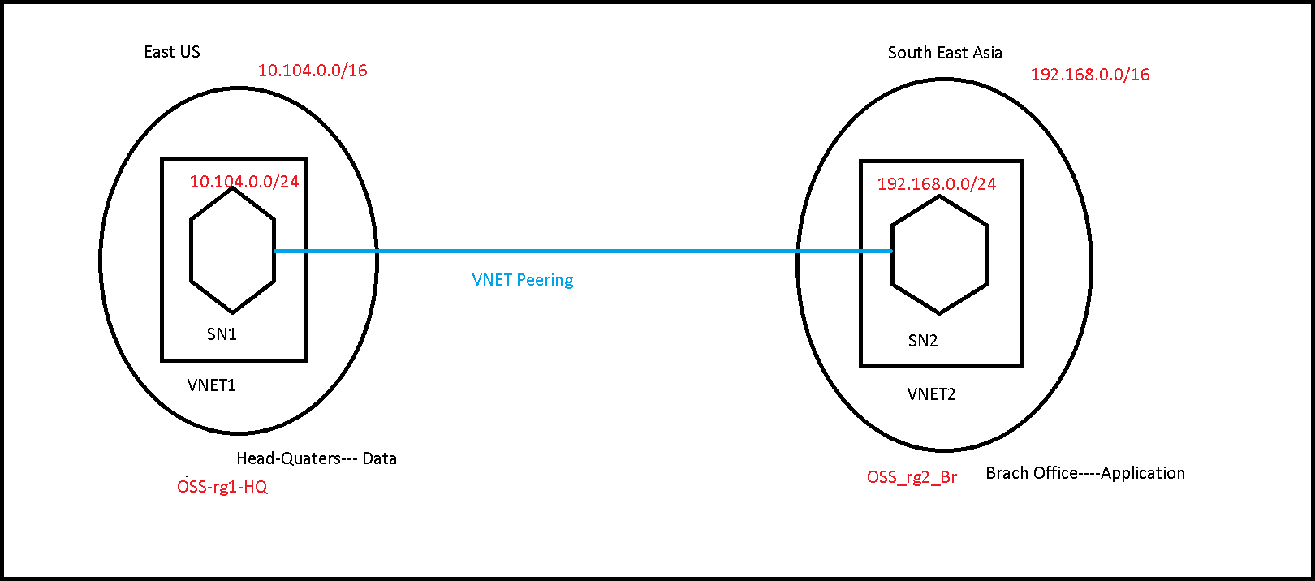

Step1: Create virtual networks in the aforementioned region

Step A: Create First Virtual Network in HeadQuaters (East US) Region CIDR VNET: 10.104.0.0/16

CIDR Subnet: 10.104.0.0/24

Resource Group Name: OSS_rg1_HQ VNET Name: VNET1

Subnet Name: SN1 Location: East US

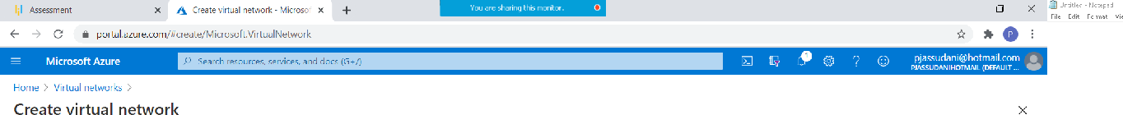



**"' Ju k ’ ”" ’ ' "*” '

Create virtual network

Basics IP Addresses S ecur ity Taps Revi eve ci eaie







Create virtual network

Basi cs I P Ad dI esses Secu ri ty Tags Revi eve c i ea ie bast'o c s I ° ' "" ^!°



Create virtual network

Ta gs a i .° n a'in e'"la I r›’e* ga'rs th a I I ab Ie ;' ou I c’: aI egor ize%e s a r›* ces a nd ’' ie\\ c c sc I i da I e‹I b ilI in g b\’ a pI;' in g th e sa m e ta y Ic

)‘t c Iha t “i f ”'a*› cr°*a te ta s a nd t h.° cha •’’res curge s et’t n 'o'n’’c I er ta bs ' ' ou r I a‹ s ,'x iI I be au I a ma I ica II’ u da I e fi



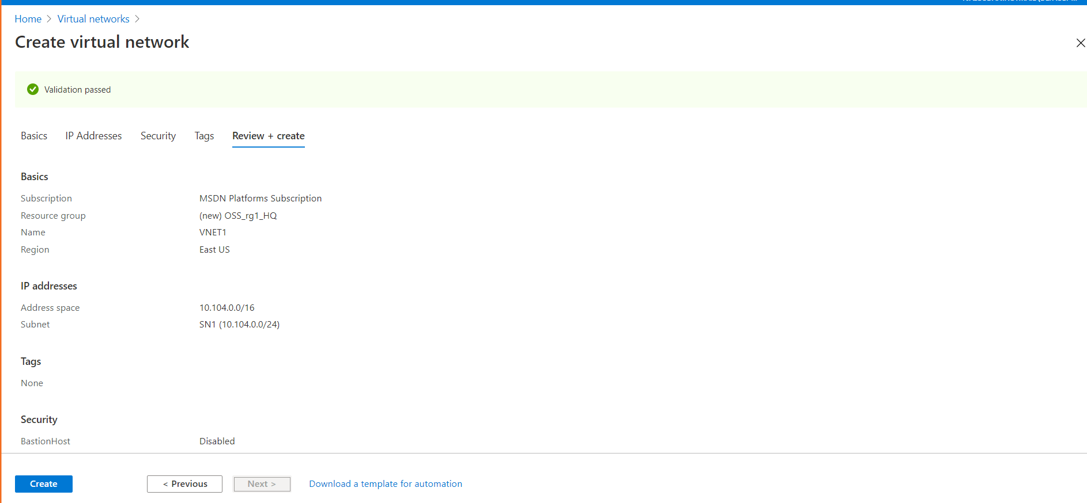

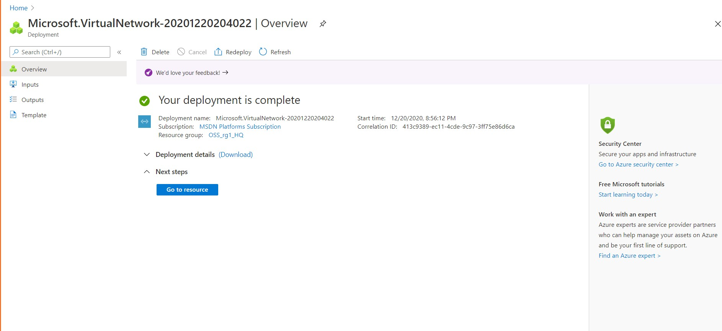

Virtual Network with Subnet is created in HeadQuaters (East US) Region.

Step B: Create Second Virtual Network in Branch Office (South East Asia) Region

CIDR VNET: 192.168.0.0/16 CIDR Subnet: 192.168.0.0/24

Resource Group Name: OSS_rg2_Br VNET Name: VNET2

Subnet Name: SN2 Location: South East Asia

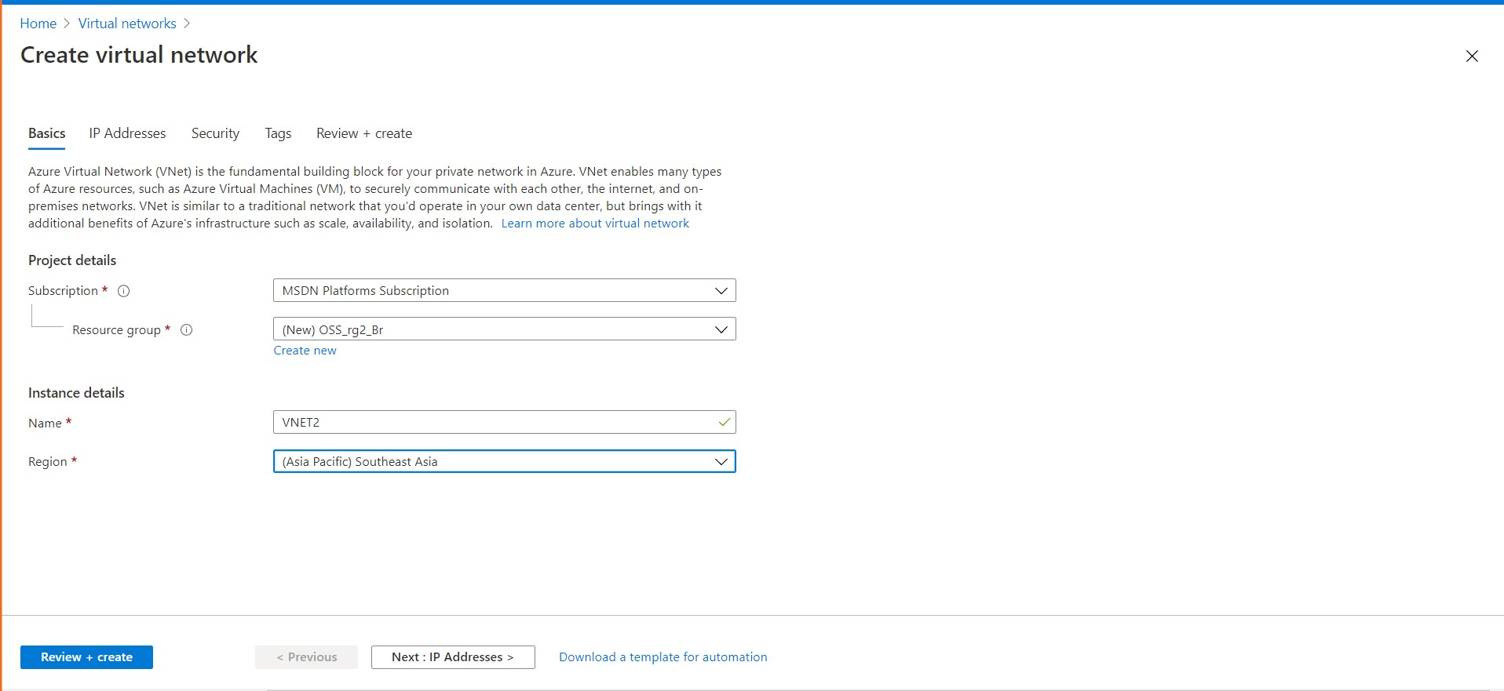



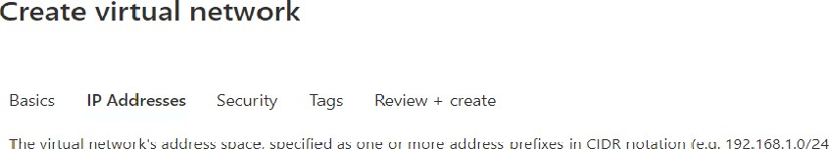

A F ' 6 a es s spa : e ' '

Suuu< n< n. < pz

D ‘ I ”d a- m p -a r e . iI i” -a c r



-tu k

Create virtual network

Bas cs P Ad d esses Secu ri ty Tags Rev eve c i ea te

@ E naIo e



Ju k

Create virtual network

d rr p a a

la gs a i .° n a'in e'"la I r›’e'pa'rs th aI I ab Ie '' ou I o’: a I ego r ize%e s a u›* ces a n fi ’' ie\\ c c sc I i da I e‹I bilI in g b\’ a pI' ' in g th e sa me ta ¿ I

)‘' c’ ha t“ f ”'a*› cr°*aie ta s a led t h.= cha •’’res curge set’t n* 'o'n’’c I er ta bs ' "our I a‹ s ,'x iII be a u I oma I ica II’ u daI ed



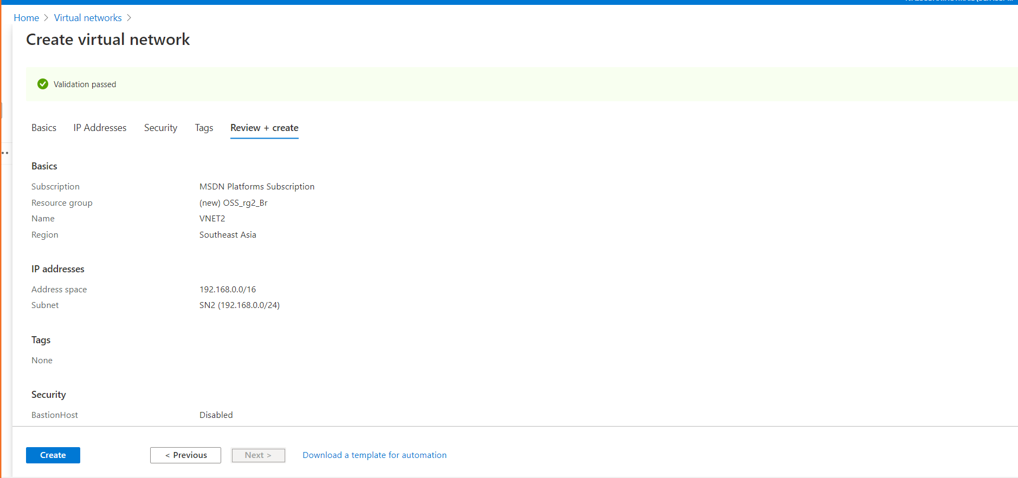

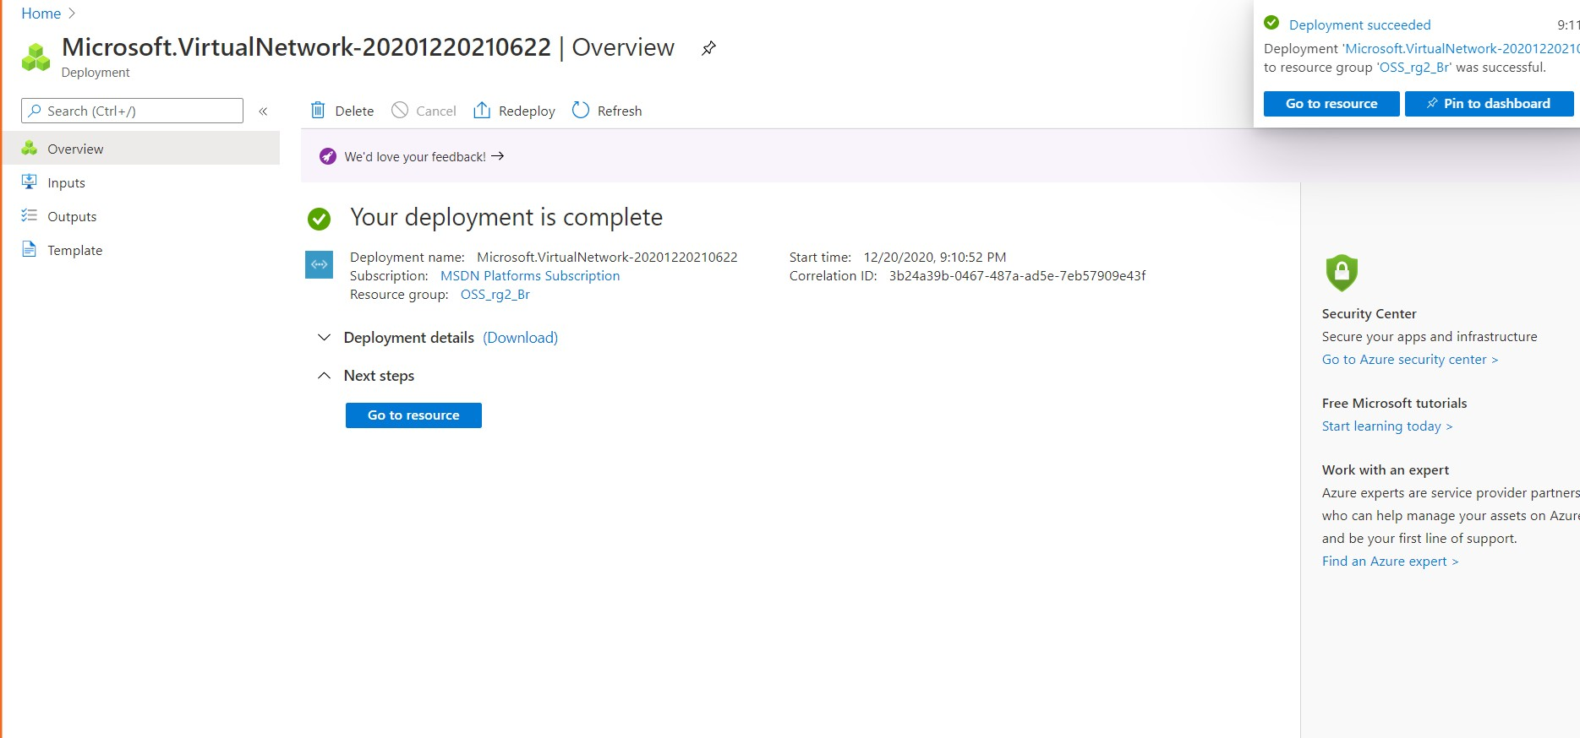

Step2: Create test virtual machines in both the virtual networks

Step A: Create First Virtual Machine in HeadQuaters (East US) Region Resource Group Name: OSS_rg1_HQ

Virtual Machine Name: VM1-HQ

VNET Name: VNET1

Subnet Name: SN1 Location: East US

OS Type: Windows 2016 Datacenter-Gen1 Instance Size: Standars_DS1_v2

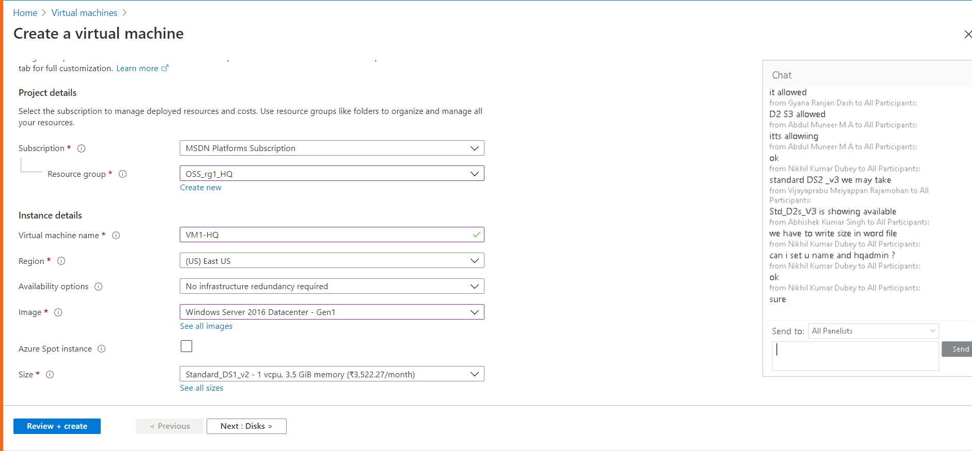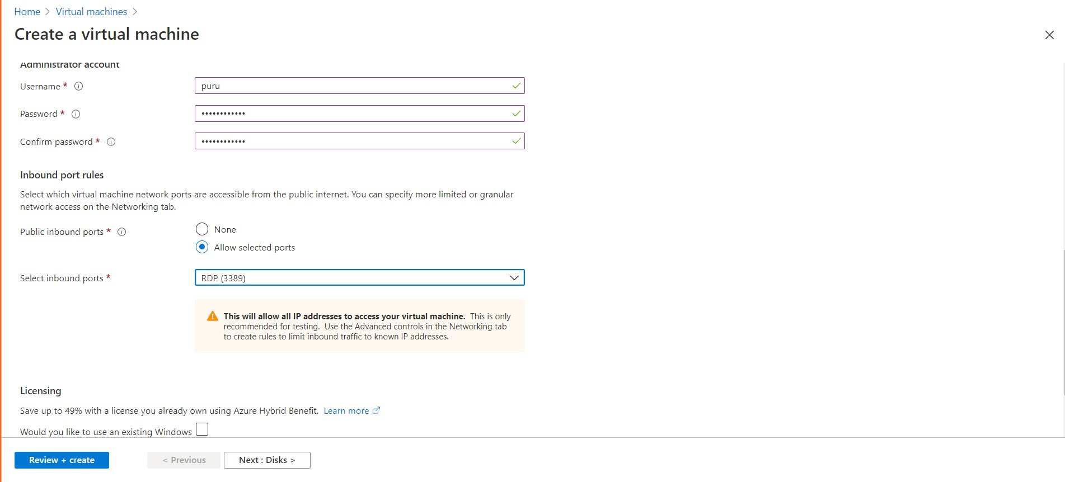





Create a virtual machine

os disk type * O

Data disks

Advanced

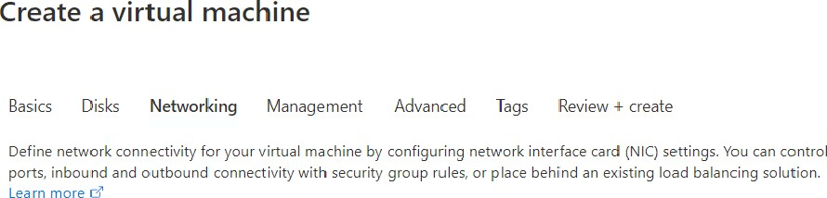

Pubs +c + P O



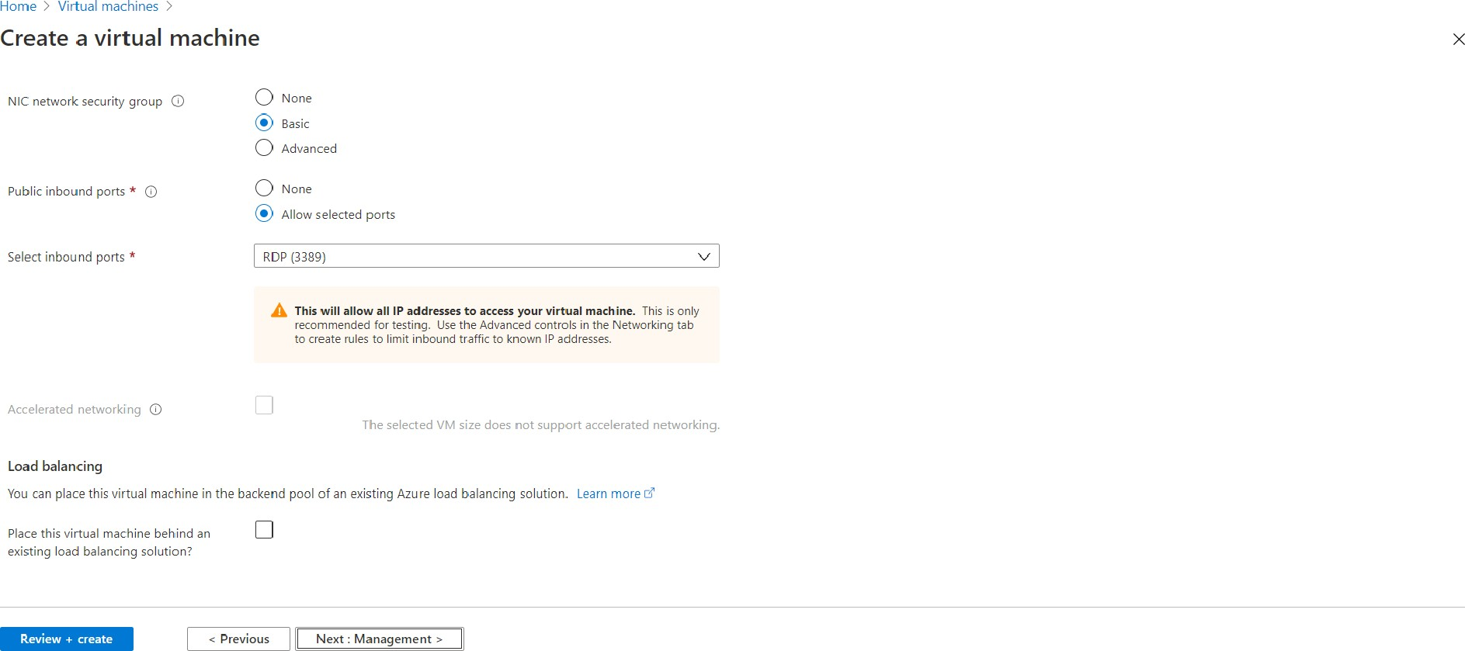



Create a virtual machine

Basics Disks Networking Management Advanced Tags Review create

Con figure m onitoring and manag emen I a tio ns for you r VM

Azure Security Center

All be Germany CenI e r pro vides uniTied security m anagemenI a nd adva nced threat protection across hybrid cIaud workIaads.

Q You + su bsc +' t 'a n 's ote cI ed b Azure S e curit Cente+ bas ie lan.

Identity

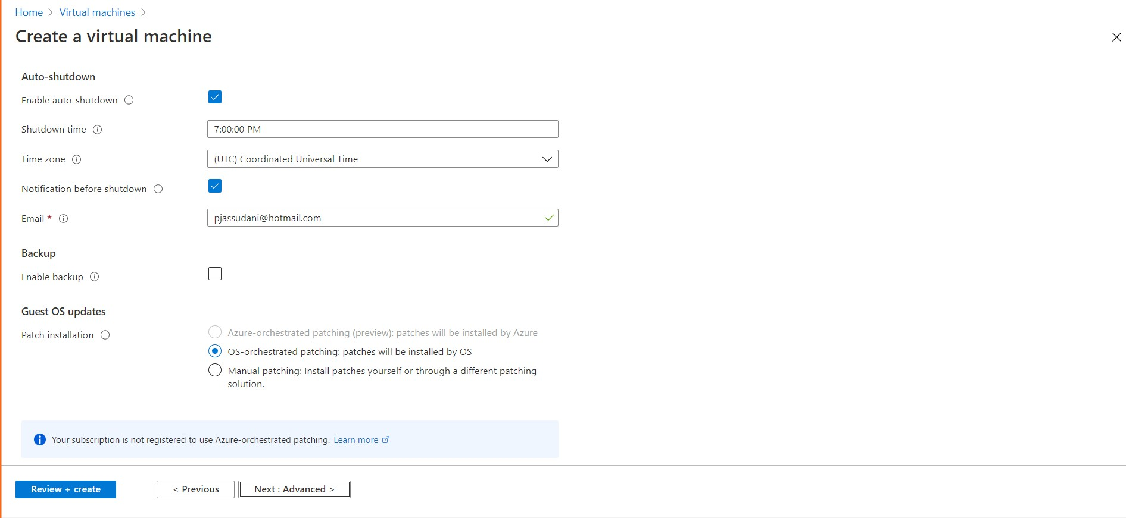

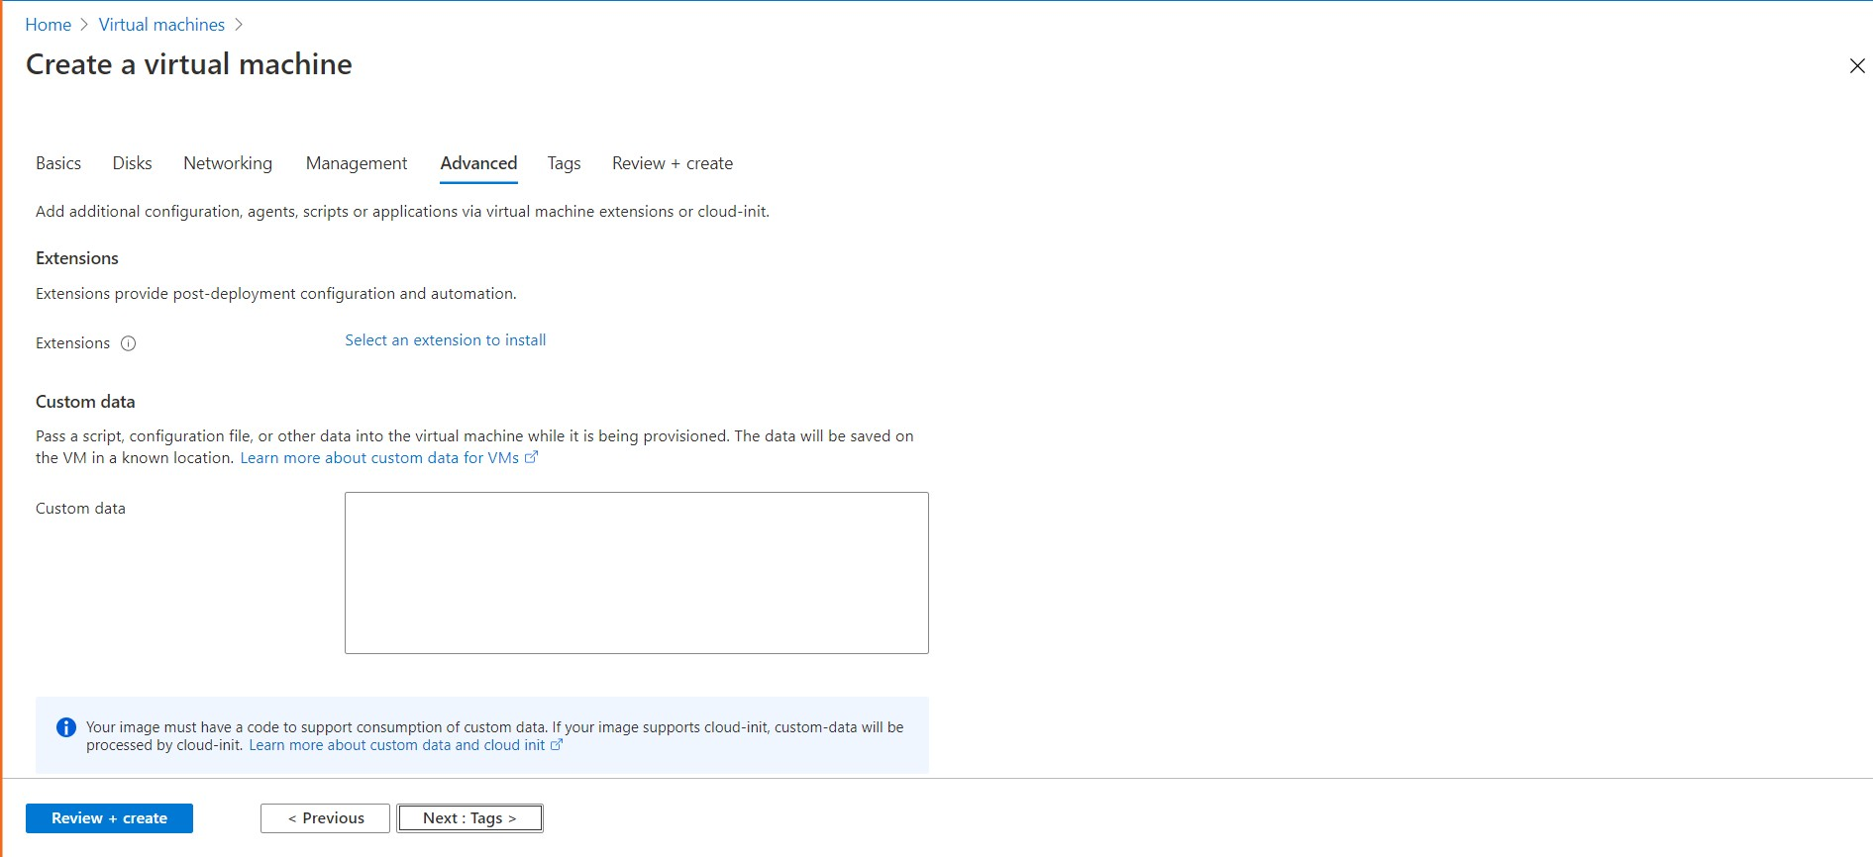



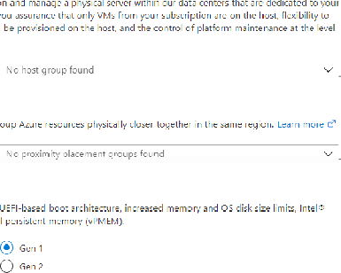

Create a virtual machine

M *m or s bscript on th ad will

Proximity p acement group

P ox' m p acement groups allow you to gr

P ox' m p acement group @

Generation 2'VMs support features such as sewage Gu a d xtens ons (SGD, and v nua

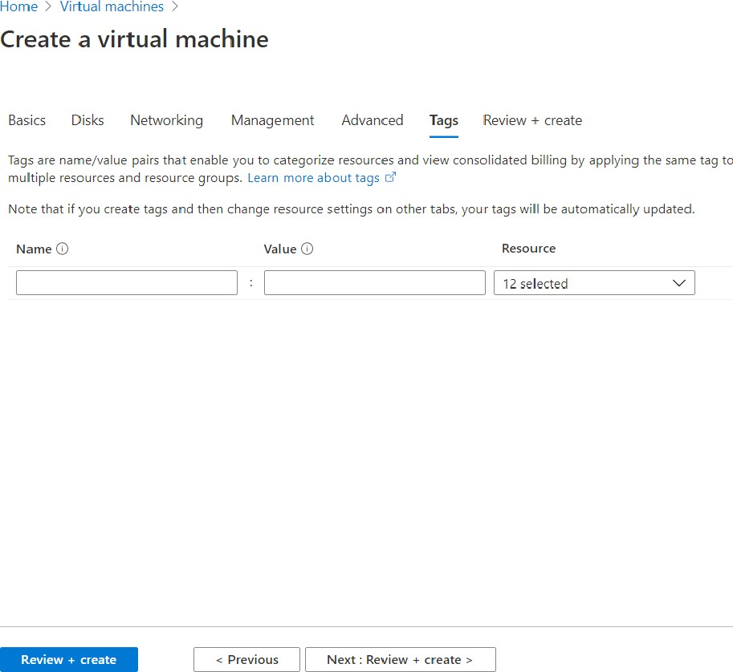

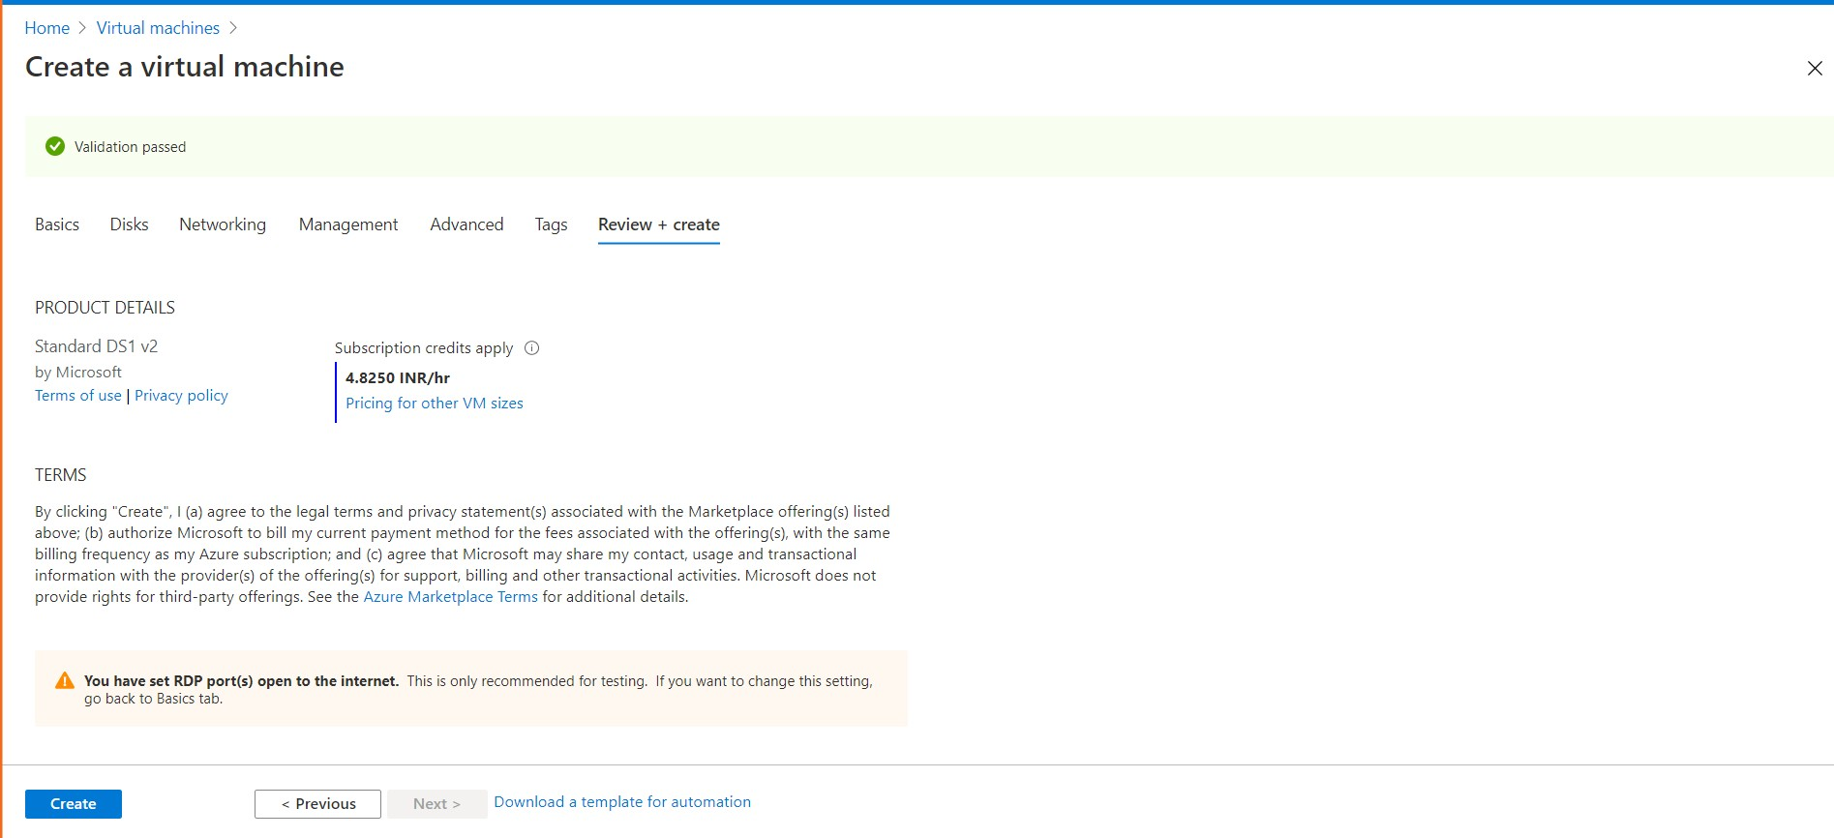

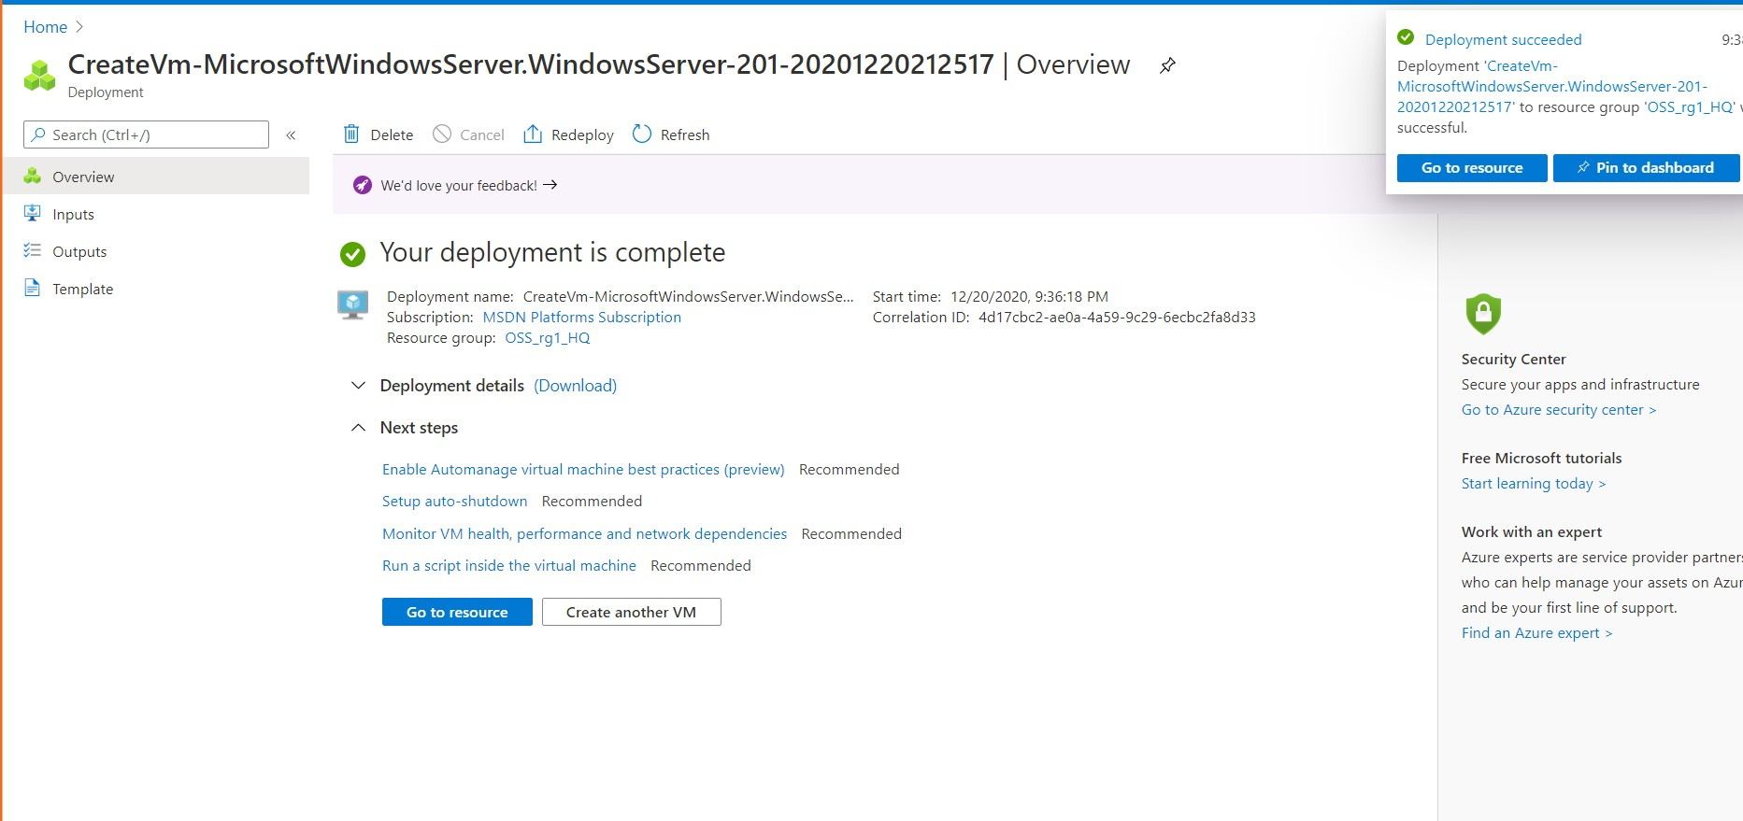

Step B: Create Second Virtual Machine in Branch Office (South East Asia) Region Resource Group Name: OSS_rg2_Br

Virtual Machine Name: VM2-BR

VNET Name: VNET2

Subnet Name: SN2 Location: South East Asia

OS Type: Windows 2016 Datacenter-Gen1

Instance Size: Standars_DS1_v2

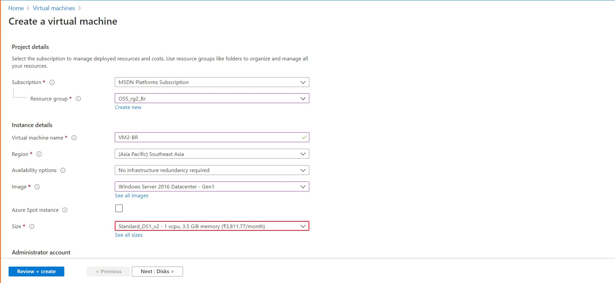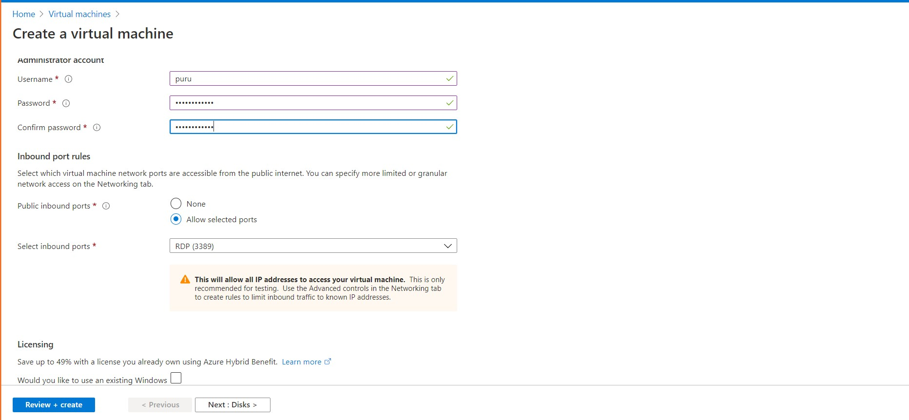





Pubs +c + P O

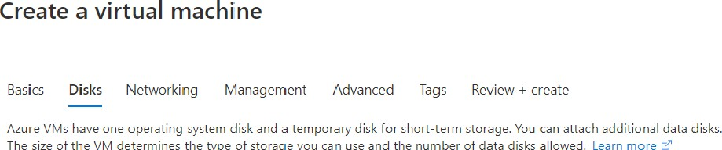

os ai°k type * O

Advanced



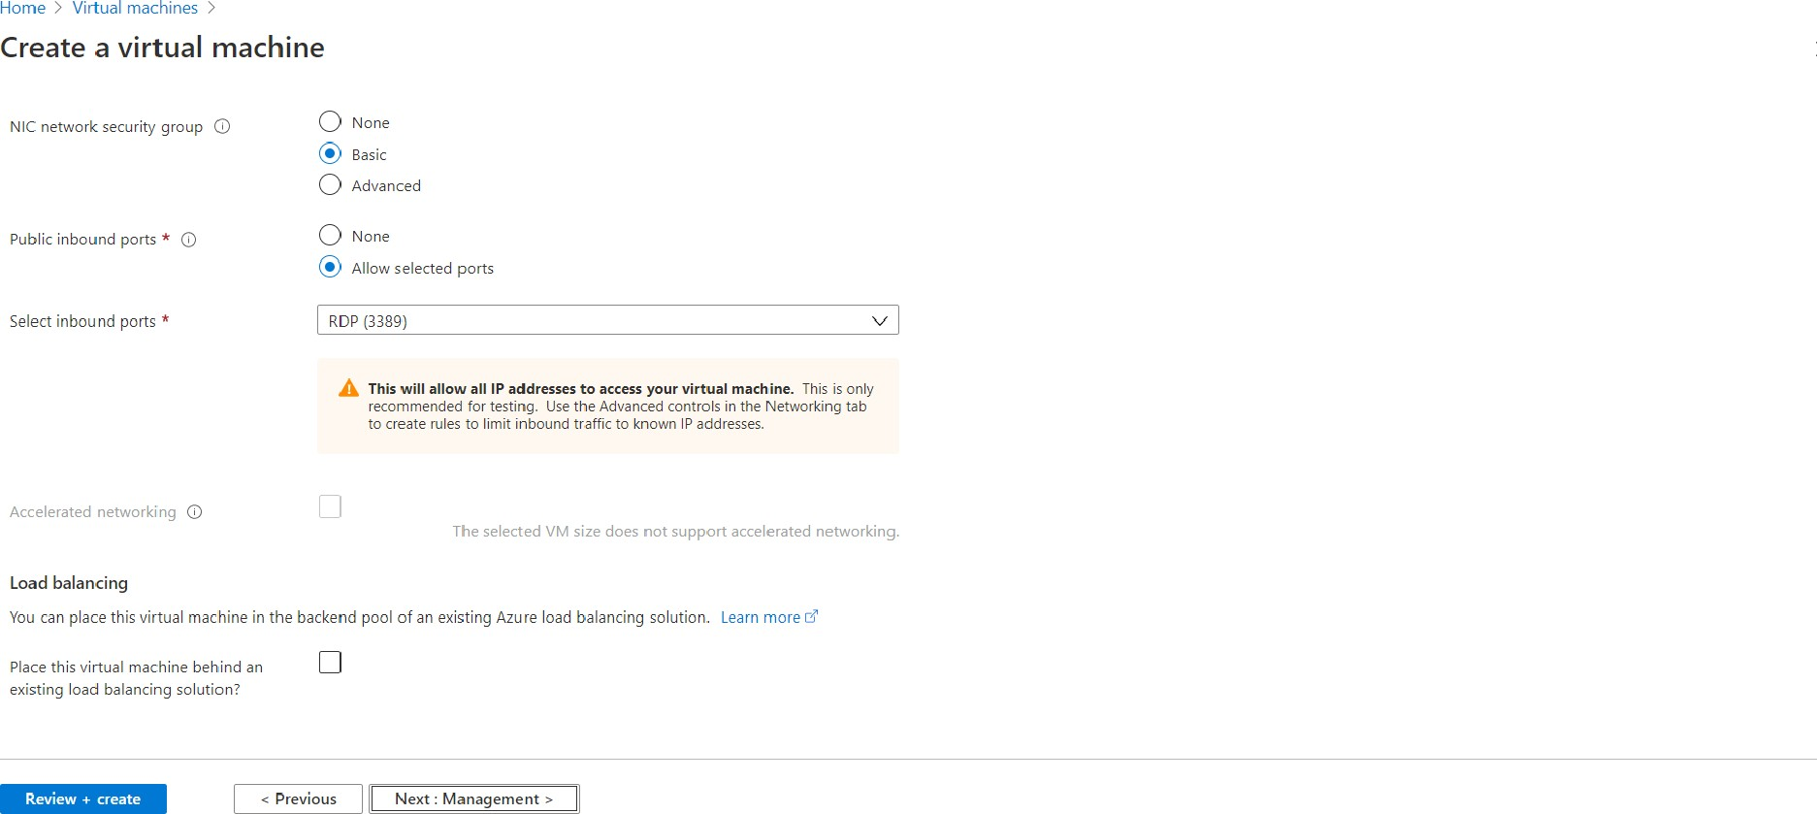



Create a virtual machine

Basics Disks Networking Management Advanced Tags Review create

Con figure m onitoring and manag emen I a tio ns for you r VM

Azure Security Center

All be Germany CenI e r pro vides uniTied security m anagemenI a nd adva nced threat protection across hybrid cIaud workIaads.

Q You + su bsc +' t 'a n 's ote cI ed b Azure S e curit Cente+ bas ie lan.

Identity

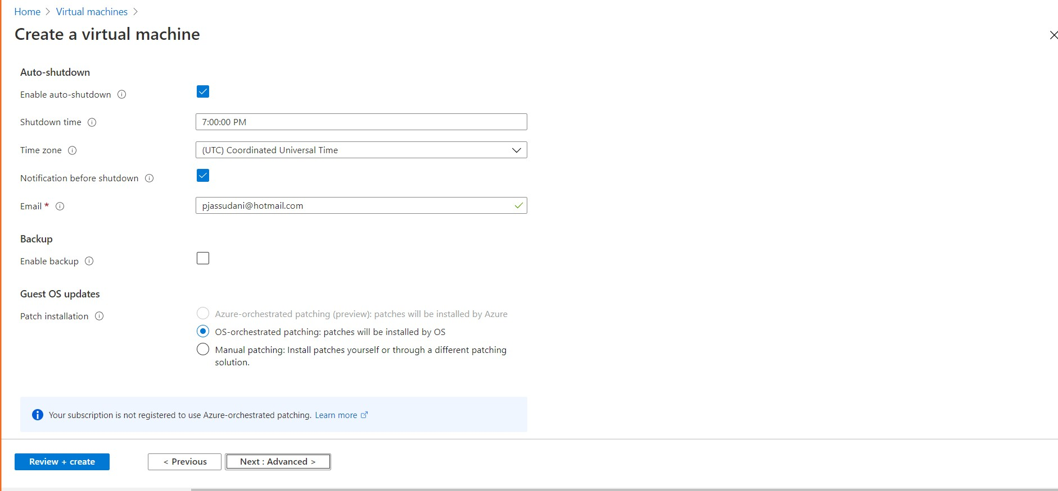

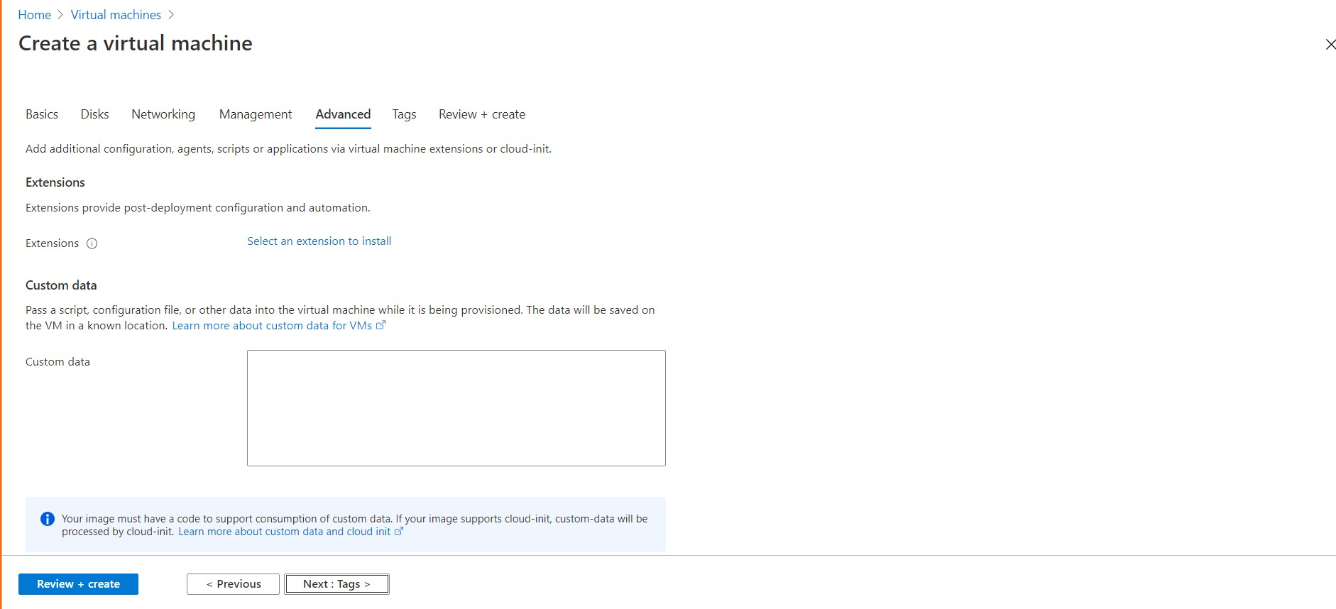



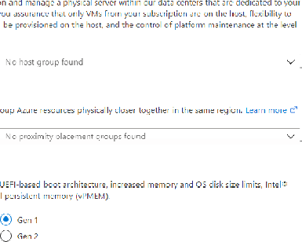

Create a virtual machine

M *m or s bscript on th ad will

Proximity p acement group

P ox' m p acement groups allow you to gr

P ox' m p acement group @

Generation 2'VMs support features such as sewage Gu a d xtens ons (SGD, and v nua



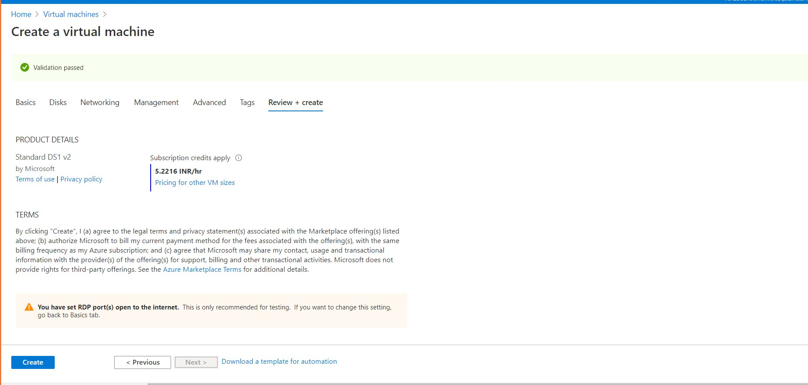

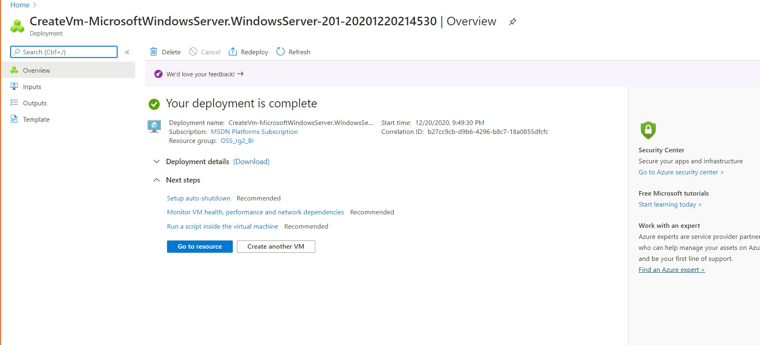

1. Step 3: Establish the connectivity between both the networks via VNet peering
   1. First got to virtual Networks Tab
   2. Go to First Virtual Network i.e. VNET1
   3. Go to peerings tab in VNET1

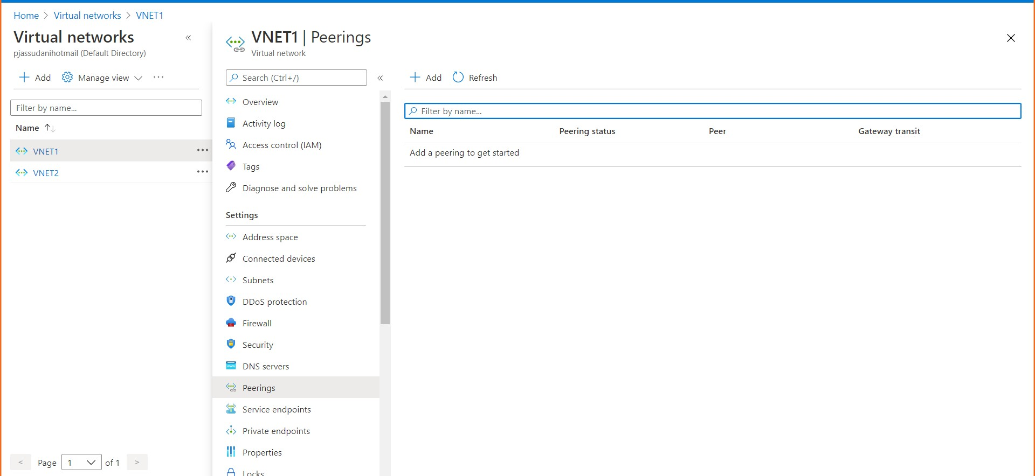

* 1. Click on Add and do the setting shown in the snapshots below

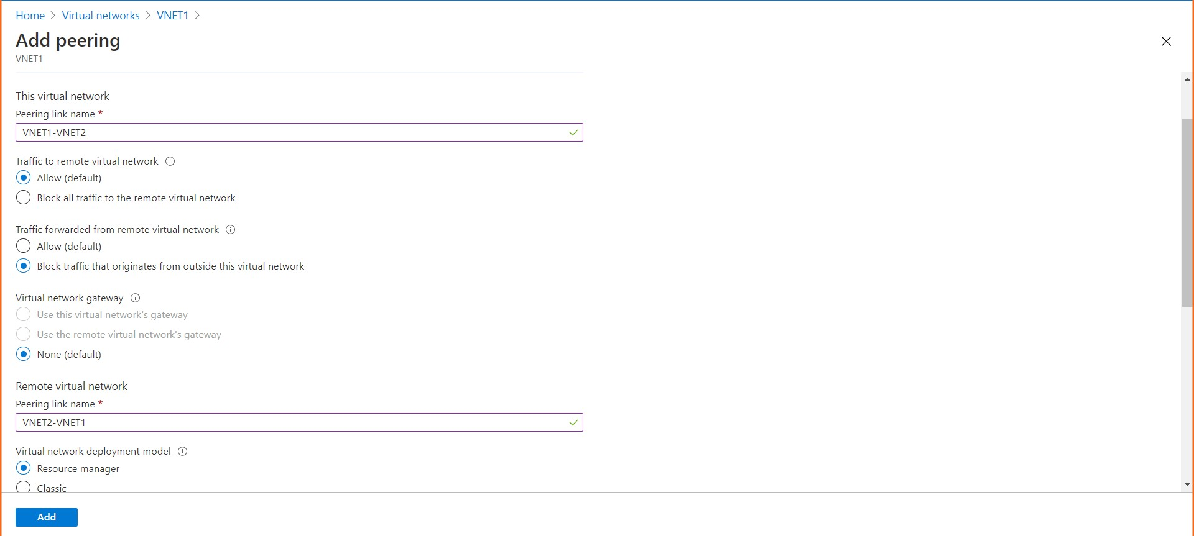

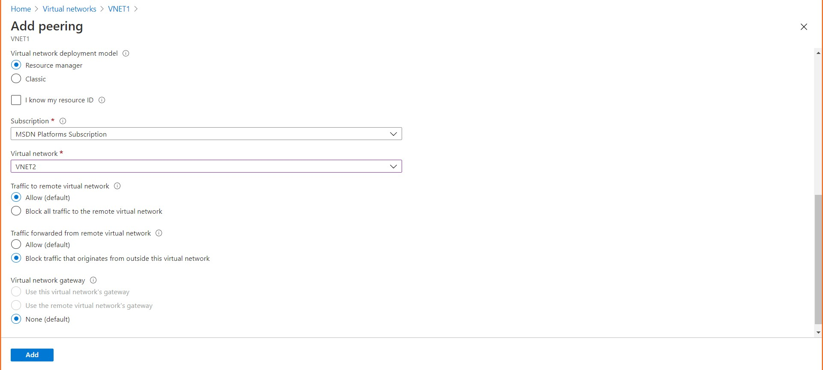

Now click on Add

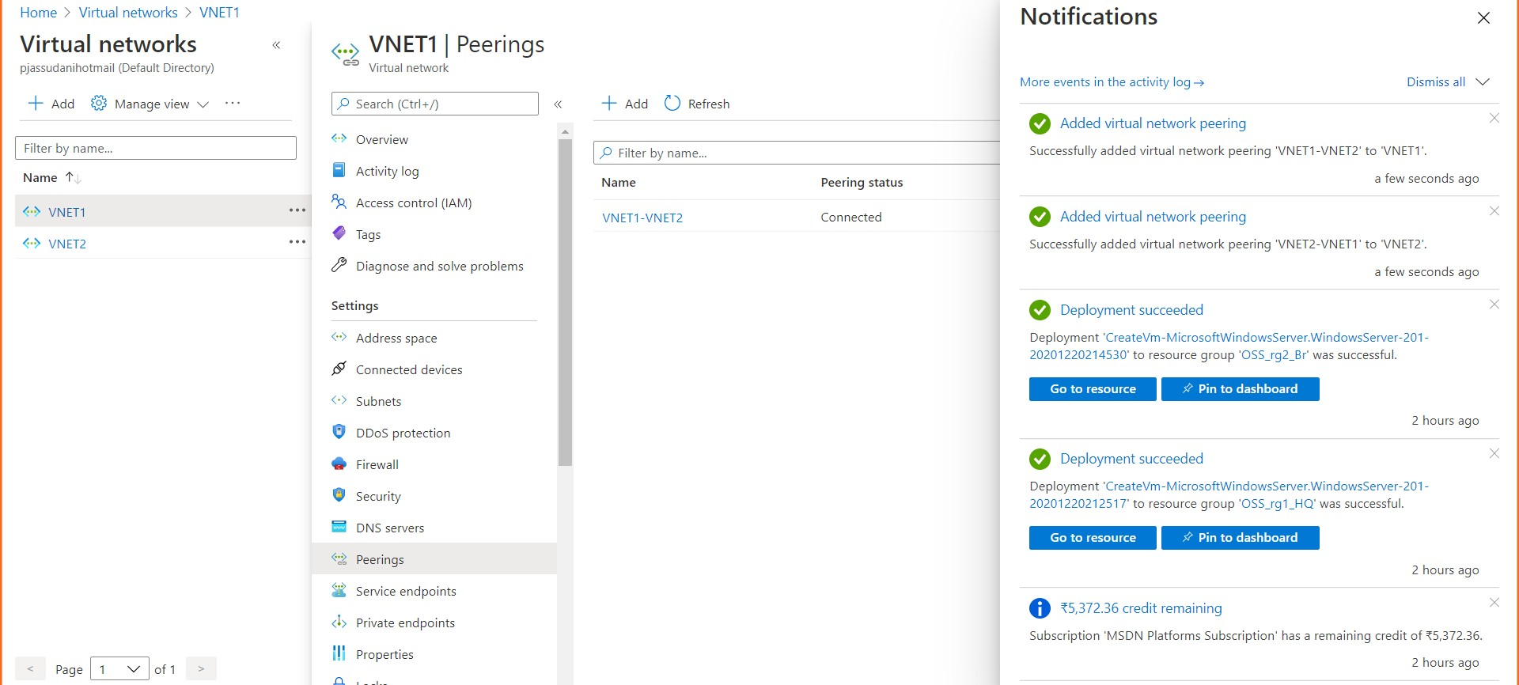

1. Step4: Ensure connectivity is established properly
   1. 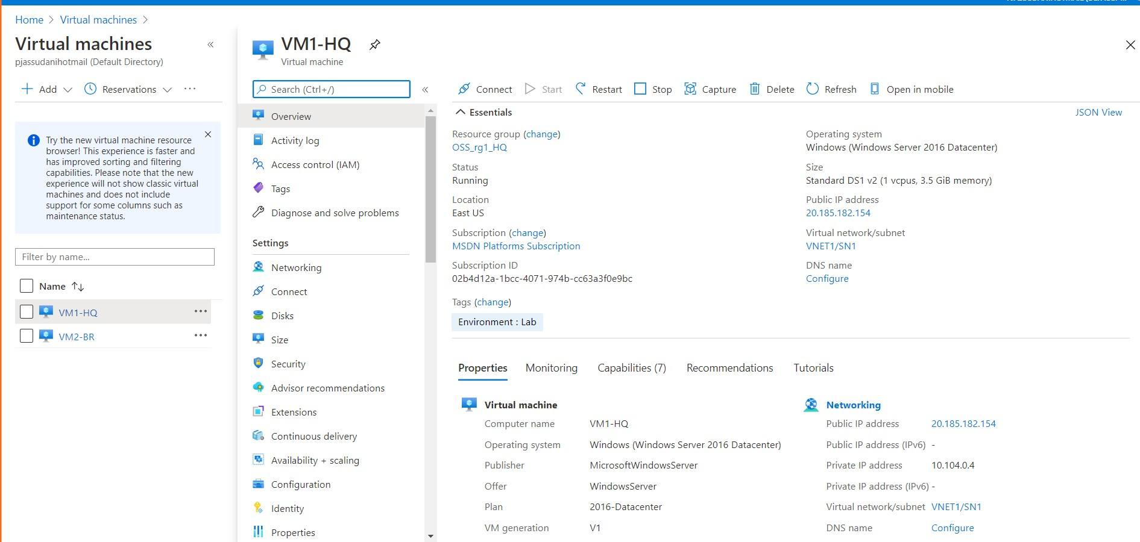Connect to First Virtual Machine (VM1-HQ) East US

Copy public IP and paste it by doing MSTSC

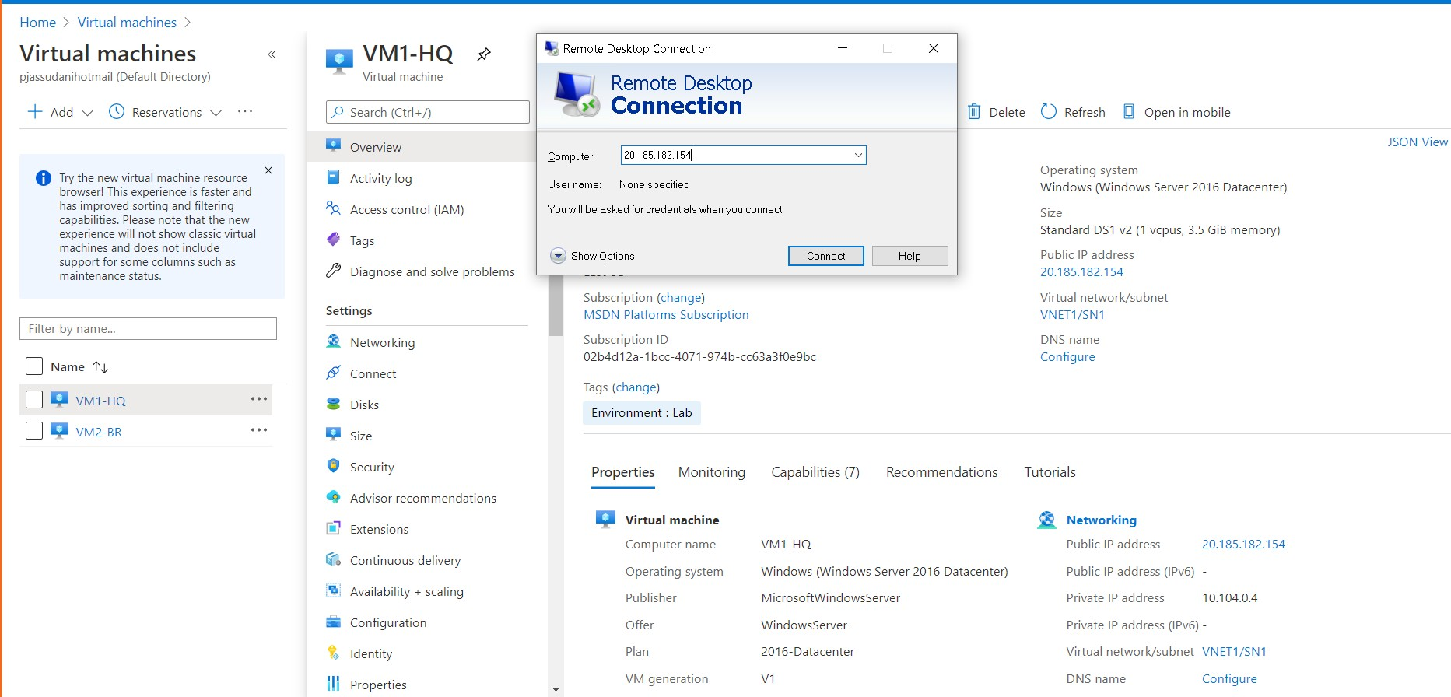

Put username and password

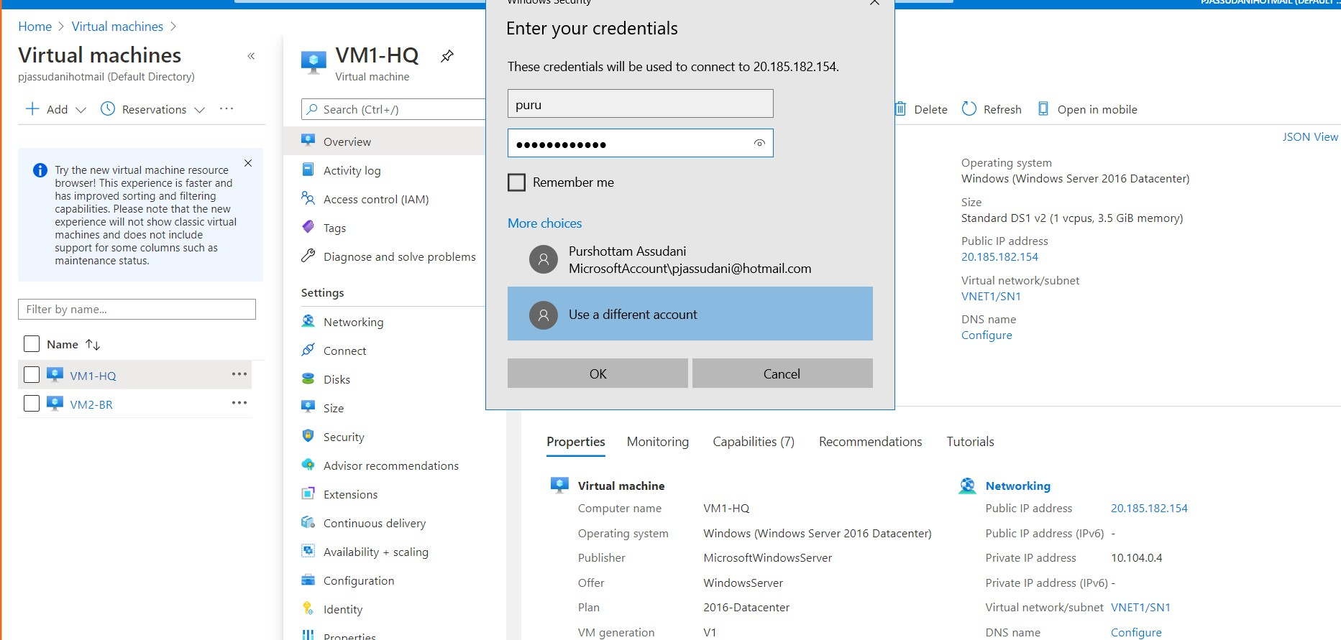

* 1. Connect to Second Virtual Machine (VM2-Br) South East Asia

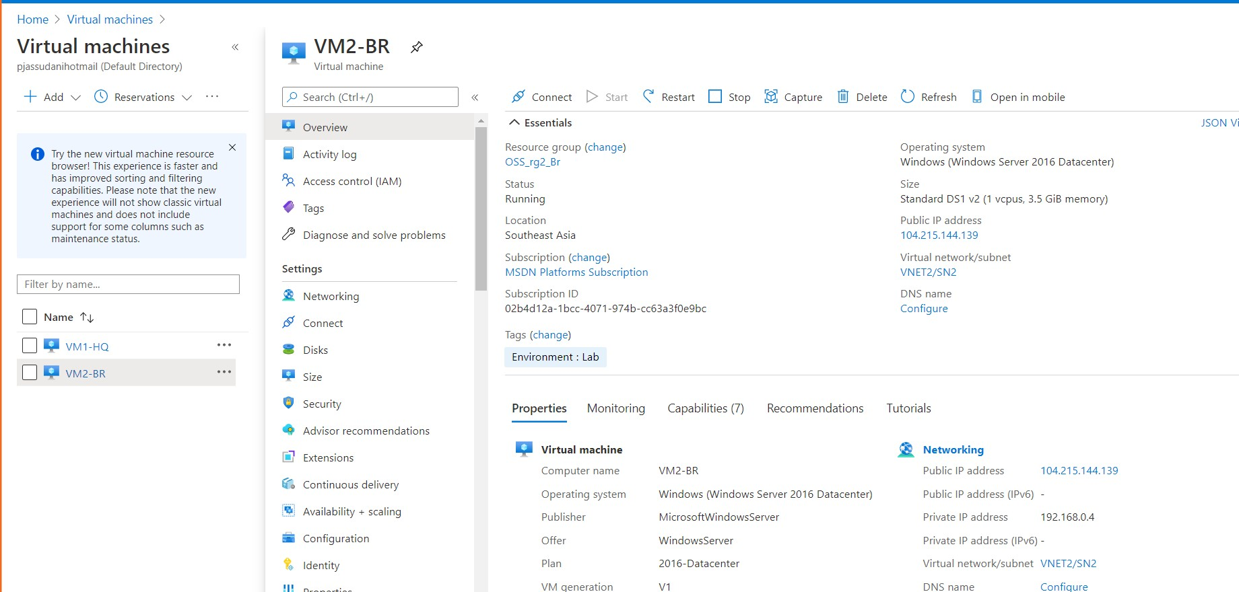

Copy public IP and paste it by doing MSTSC

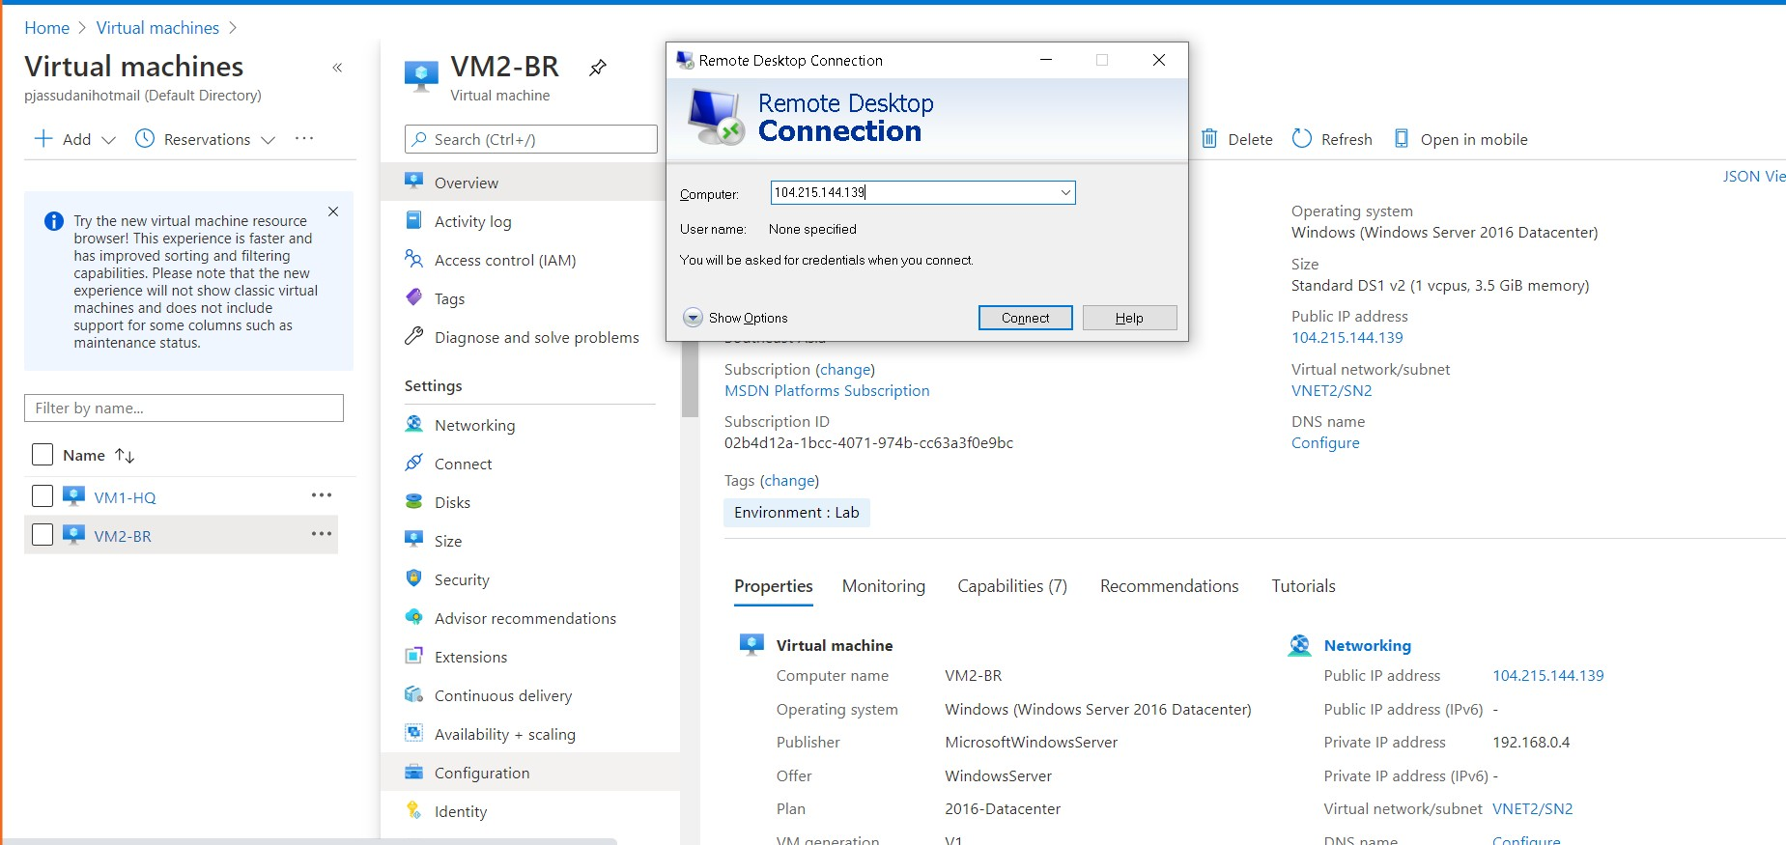

Put username and password

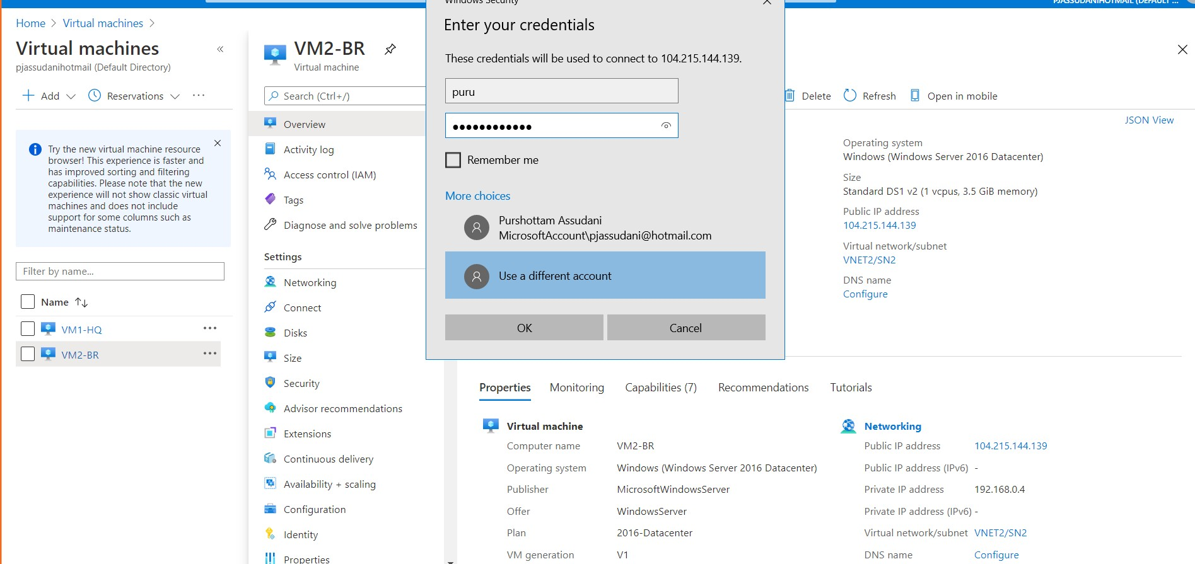

C . Run firewall.cpl in both VMs and then in Advanced Settings allow ICMP traffic in Inbound Rules

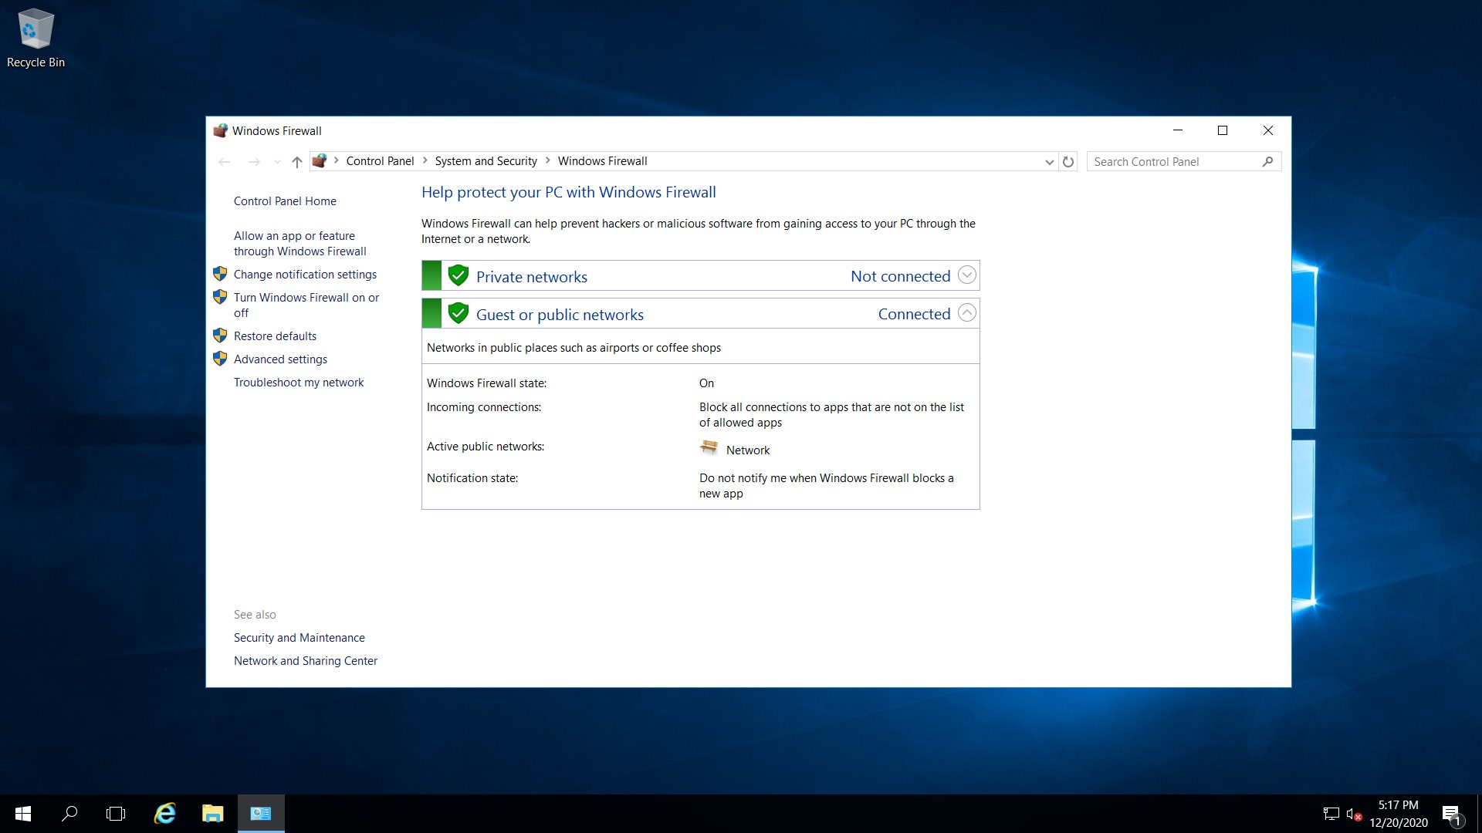

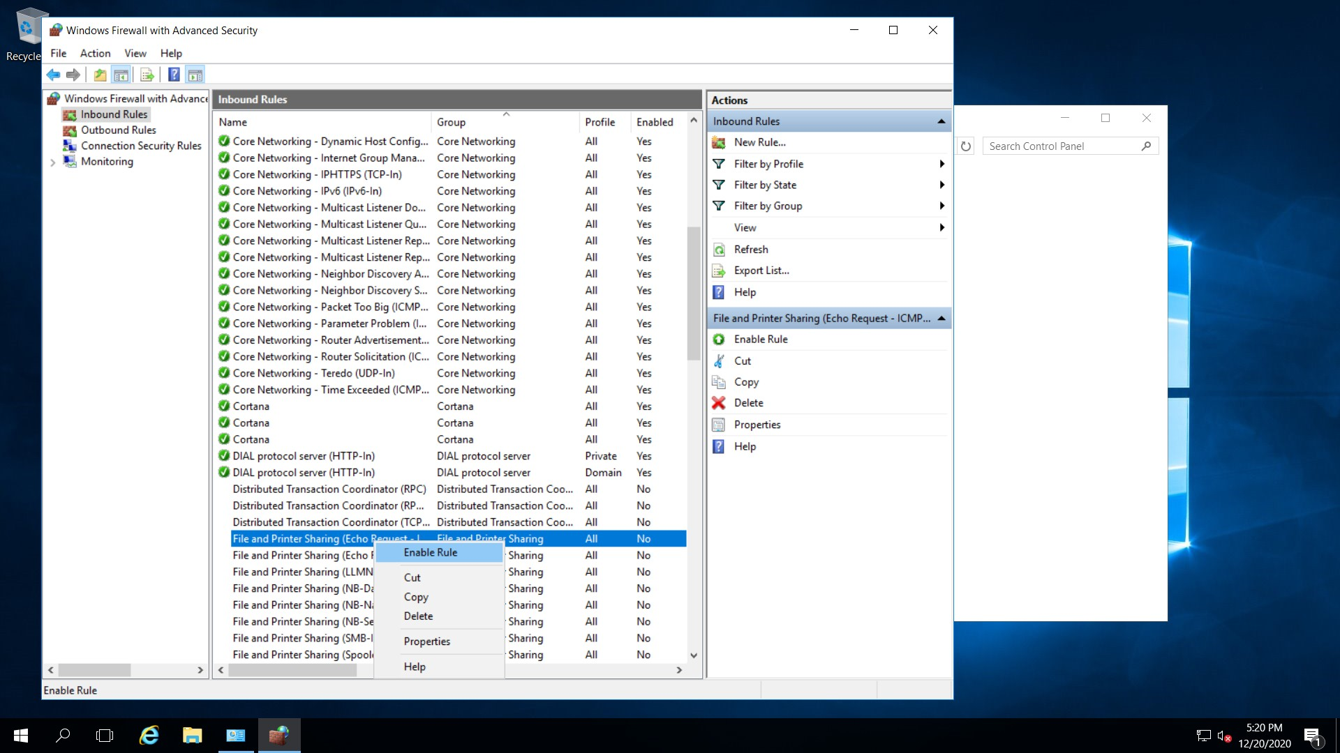

D.Go to Command prompt on both the VMs by typing cmd

Then type ipconfig to check the ips of both VMs and then try to ping both VMs with each other by the command:

Ping <IP of other VM>

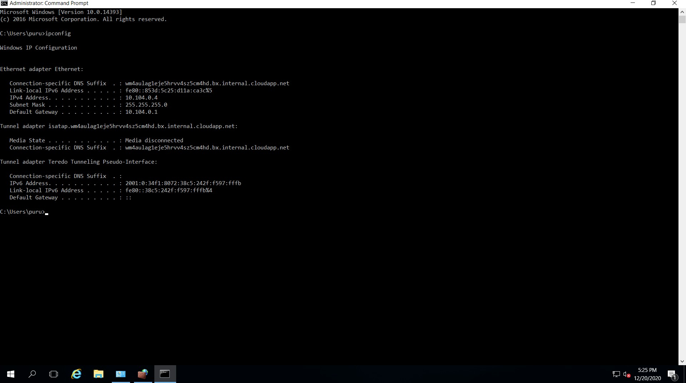

Ping 192.168.0.4

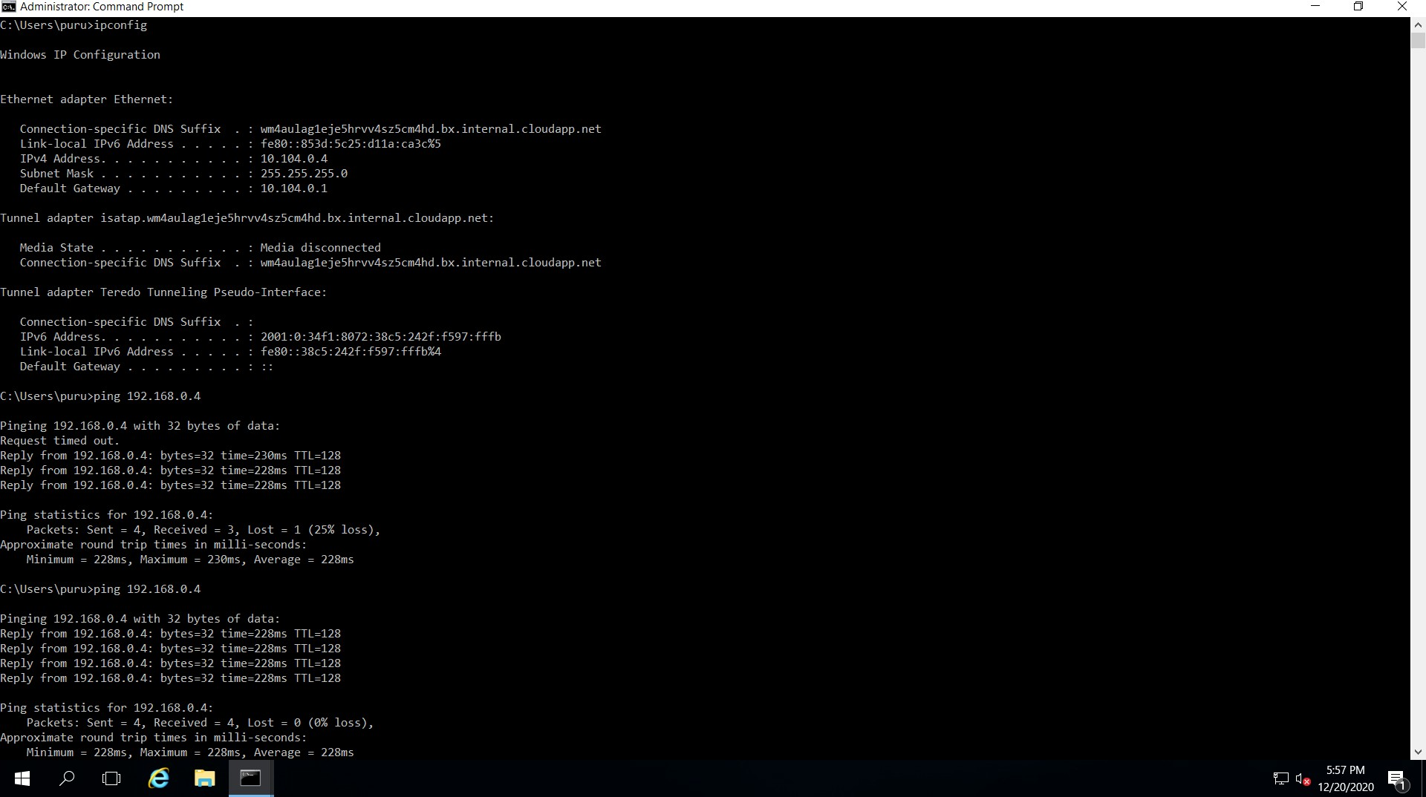

Ping 10.104.0.4

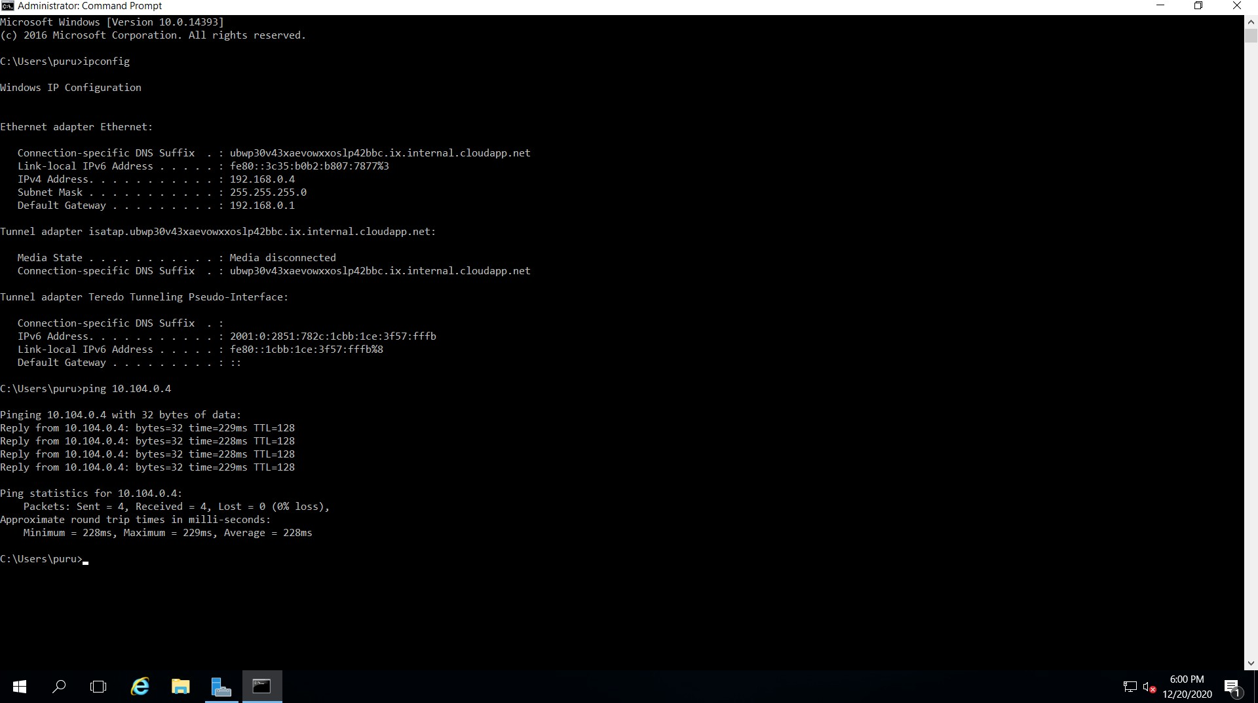

**Both VMs are able to ping each other and Hence the project is completed successfully.**